Vertical Tail Reference Data
Table 2.1: Vertical tail data of home build aircraft
Type | 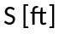² | 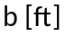 | 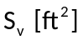 | 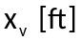 | 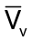
PIK-21 | 76.4 | 17.0 | 3.49 | 10.5 | 0.028
Durable RD-03C | 119 | 28.7 | 8.35 | 12.5 | 0.031
Piel CP-750 | 118 | 26.4 | 9.49 | 12.9 | 0.039
Piel CP-90 | 104 | 23.6 | 7.64 | 11.9 | 0.037
Pottier P-50R | 80.7 | 20.3 | 11.3 | 10.4 | 0.072
Pottier P-70S | 77.5 | 19.4 | 4.36 | 10.5 | 0.031
O-O Aerosport | 80.7 | 21.3 | 6.86 | 10.0 | 0.040
Aerocar Micro-Inp | 81.0 | 27.0 | 7.15 | 6.27 | 0.020
Coats SA-III | 112 | 25.0 | 7.53 | 10.6 | 0.028
Sequiois 300 | 130 | 0.0 | 16.5 | 13.2 | 0.055
Old Hume OH-4B | 125 | 25.0 | 6.73 | 12.5 | 0.027
Procter Petrel | 135 | 30.0 | 11.7 | 11.4 | 0.033
Bede BD-8 | 96.7 | 19.3 | 6.89 | 8.65 | 0.032

Table 2.2: Vertical tail data of agricultural aircraft
Type | ²
PEL-104 | 167 | 36.5 | 20.3 | 16.1 | 0.054
PEL-106A | 306 | 48.5 | 31.0 | 17.1 | 0.036
PEL-M18 | 431 | 58.1 | 28.5 | 18.5 | 0.011
Embraer EMB-201A | 215 | 38.4 | 13.0 | 14.1 | 0.022
Cessna Ag Busky | 205 | 41.7 | 18.0 | 16.0 | 0.034
Schweizer Ag-Cat B | 392 | 42.3 | 30.0 | 13.5 | 0.024
Aero Boero 260Ag | 189 | 35.8 | 9.94 | 15.1 | 0.022
Let S-37A | 256 | 40.1 | 32.1 | 15.3 | 0.033
Hal HA-31 | 251 | 39.4 | 20.7 | 16.6 | 0.035
IAR-S22 | 280 | 42.0 | 22.9 | 17.9 | 0.035
Piper PA-36 | 226 | 38.8 | 29.9 | 16.5 | 0.032

Table 2.3: Vertical tail data of single propeller aircraft
Type | ²
Cessna 207 Skywagon | 174 | 35.8 | 16.0 | 18.0 | 0.046
Cardinal RG | 174 | 35.5 | 17.4 | 13.5 | 0.038
Skylane RG | 174 | 35.8 | 8.6 | 15.8 | 0.047
Piper Cherokee Lance | 175 | 32.8 | 13.8 | 15.3 | 0.037
Piper Warrior | 170 | 35.0 | 12.5 | 13.2 | 0.026
Turbo Saratoga SP | 178 | 36.2 | 15.9 | 15.2 | 0.038
Bellance Skyrocket | 183 | 35.0 | 18.1 | 13.2 | 0.037
Grumman Tiger | 140 | 31.5 | 8.4 | 12.6 | 0.024
Rockwell Commander | 152 | 32.8 | 17.0 | 11.4 | 0.039
Trago Hills SAE-2 | 120 | 30.7 | 17.1 | 18.6 | 0.086
Scottish Aviation Bullfinch | 129 | 33.8 | 22.7 | 11.9 | 0.062

Table 2.4: Vertical tail data of twin propeller aircraft
Type | ²
Cessna 310R | 179 | 36.9 | 26.1 | 15.9 | 0.063
Cessna 402B | 196 | 39.9 | 37.9 | 16.5 | 0.080
Cessna 414A | 226 | 44.1 | 41.3 | 17.0 | 0.071
Cessna T303 | 189 | 39.0 | 23.2 | 16.5 | 0.052
Conquest I | 225 | 44.1 | 41.3 | 17.1 | 0.071
Piper PA-31P | 229 | 40.7 | 30.1 | 17.2 | 0.056
Piper PA-44-120T | 184 | 38.6 | 21.5 | 14.4 | 0.044
Piper Chieftain | 229 | 40.7 | 329.5 | 17.3 | 0.055
Piper Cheyenne I | 229 | 42.7 | 26.5 | 16.5 | 0.045
Piper Cheyenne III | 293 | 47.7 | 43.6 | 20.8 | 0.065
Beech Duchess | 181 | 38.0 | 25.6 | 14.2 | 0.053
Beech Duke B60 | 213 | 39.3 | 28.8 | 17.4 | 0.060
Lear Fan 2100 | 163 | 39.3 | 44.4 | 14.0 | 0.097
Rockwell Commander 700 | 200 | 42.5 | 39.9 | 20.5 | 0.096
Piaggio P166-DL3 | 286 | 8.2 | 30.7 | 18.3 | 0.041
Embrear EMB-121 | 296 | 46.4 | 42.6 | 17.8 | 0.055

Table 2.5: Vertical tail data of regional turboprop aircraft
Type | ²
CASA C-212-200 | 431 | 62.3 | 77.5 | 24.8 | 0.072
Shorts 330 | 453 | 74.7 | 93.1 | 27.3 | 0.075
Shorts 360 | 453 | 74.7 | 91.4 | 33.9 | 0.091
Beech 1900 | 303 | 54.5 | 47.5 | 26.5 | 0.076
Beech B200 | 303 | 54.5 | 52.3 | 20.5 | 0.065
Cessna Conquest I | 225 | 44.1 | 41.3 | 17.1 | 0.071
Cessna Conquest II | 254 | 49.3 | 43.5 | 18.7 | 0.065
GA Ic | 610 | 76.3 | 117 | 35.4 | 0.087
GAF N22B | 324 | 54.2 | 70.2 | 21.6 | 0.086
Fokker F-27-200 | 754 | 95.2 | 153 | 36.0 | 0.077
DeHavilland Cananda DHC-6 | 420 | 65.0 | 82.0 | 25.7 | 0.077
DeHavilland Cananda DHC-7 | 860 | 93.0 | 170 | 35.7 | 0.076
DeHavilland Cananda DHC-8 | 585 | 84.0 | 190 | 31.4 | 0.121
Embraer EMB-120 | 409 | 64.9 | 74.3 | 27.3 | 0.076
BAe 31 | 270 | 52.0 | 83.1 | 20.7 | 0.120
Metro III | 309 | 57.0 | 56.0 | 27.9 | 0.089

Table 2.6: Vertical tail data of business jets
Type | ²
Dassault Falcon 10 | 259 | 42.9 | 48.9 | 14.4 | 0.063
Dassault Falcon 20 | 440 | 53.5 | 81.8 | 18.1 | 0.063
Dassault Falcon 50 | 495 | 61.9 | 106 | 18.7 | 0.064
Cessna Citation 550 | 260 | 43.9 | 50.9 | 18.2 | 0.081
Cessna Citation II | 323 | 51.7 | 53.0 | 19.36 | 0.062
Cessna Citation III | 312 | 55.5 | 70.2 | 20.5 | 0.086
Canadair CL-601 Challenger | 450 | 64.3 | 96.0 | 24.9 | 0.083
Aerospatiale SN-601 | 237 | 42.2 | 45.4 | 15.7 | 0.071
Israël Aircraft Ind. Astra | 317 | 52.7 | 48.3 | 22.0 | 0.064
Israël Aircraft Ind. Westwind | 308 | 44.8 | 59.7 | 20.1 | 0.087
British Aerospace HS125-700 | 353 | 47.0 | 63.8 | 15.9 | 0.061
G.A.-III | 35 | 77.8 | 159 | 26.9 | 0.059
MU Diam.I | 241 | 43.4 | 55.9 | 17.4 | 0.093

Table 2.7: Vertical tail data of passenger transport jet aircraft
Type | ²
Boeing 727-200 | 1700 | 108 | 422 | 47.4 | 0.110
Boeing 737-200 | 980 | 93.0 | 233 | 40.7 | 0.100
Boeing 737-300 | 1117 | 94.8 | 239 | 45.7 | 0.100
Boeing 747-200B | 5500 | 196 | 830 | 102 | 0.079
Boeing 747SP | 5500 | 196 | 885 | 69.5 | 0.057
Boeing 757-200 | 1951 | 125 | 384 | 54.2 | 0.086
Boeing 767-200 | 3050 | 156 | 457 | 64.6 | 0.067
McDonnell Douglas DC-9-30 | 1270 | 108 | 168 | 50.5 | 0.062
McDonnell Douglas DC-9-50 | 1001 | 93.4 | 161 | 46.2 | 0.079
McDonnell Douglas DC-10-30 | 3958 | 165 | 605 | 64.6 | 0.060
Airbus A300B4 | 2799 | 147 | 487 | 79.5 | 0.094
Airbus A310 | 2357 | 144 | 487 | 68.5 | 0.098
Lockheed L1011-500 | 3541 | 164 | 550 | 58.2 | 0.035
Fokker F-28-4000 | 850 | 82.3 | 157 | 37.9 | 0.085
BAC 1-11 495 | 1031 | 93.5 | 117 | 31.6 | 0.038
BAe 146-200 | 832 | 86.4 | 224 | 38.9 | 0.120
Tupolev Tu-154 | 2169 | 123 | 841 | 43.3 | 0.055

Table 2.8: Vertical tail data of military trainers
Type | ²
Propeller driven
Embraer EMB-312 | 209 | 36.5 | 22.4 | 16.6 | 0.049
Pilatus PC-7 | 179 | 34.1 | 20.2 | 14.4 | 0.048
NDN 1T | 126 | 26.0 | 13.5 | 11.8 | 0.049
T-34C | 180 | 33.3 | 19.8 | 14.4 | 0.048
Epsilon | 96.9 | 26.0 | 11.0 | 13.4 | 0.058
SF-260M | 109 | 27.4 | 16.4 | 12.5 | 0.069
Yak-52 | 162 | 30.5 | 15.9 | 13.9 | 0.045
Naiva T25 | 185 | 16.1 | 18.5 | 15.7 | 0.043
Jet driven
Aero L39C | 202 | 31.0 | 37.8 | 13.9 | 0.083
Microturbo Microjet 200B | 65.9 | 24.8 | 14.5 | 10.0 | 0.089
Alphajet | 188 | 29.9 | 32.0 | 14.8 | 0.084
Aermacchi MB-339A | 208 | 35.6 | 25.5 | 12.6 | 0.043
SM S-211 | 136 | 27.7 | 21.6 | 13.5 | 0.078
PEL TS-11 | 188 | 33.0 | 24.2 | 16.8 | 0.066
CASA C101 | 215 | 34.8 | 34.4 | 15.8 | 0.072
BAe Hawk Mk1 | 180 | 30.8 | 27.0 | 12.1 | 0.059

Table 2.9: Vertical tail data of fighters
Type | ²
Dassault Mirage IIIE | 377 | 27.0 | 48.4 | 13.9 | 0.066
Dassault Mirage F1C | 269 | 27.6 | 53.9 | 13.5 | 0.098
Dassault Mirage 2000 | 441 | 29.5 | 71.8 | 13.6 | 0.075
Super Et. | 306 | 31.5 | 48.3 | 12.4 | 0.062
PR A-10A | 506 | 57.5 | 84.0 | 20.9 | 0.060
Grumman A-6A | 529 | 53.0 | 79.3 | 24.6 | 0.069
Grumman F-14A | 565 | 64.1 | 118 | 18.4 | 0.060
Northrop F-5E | 186 | 26.7 | 41.4 | 11.7 | 0.098
McDonnell Douglas F-4E | 530 | 38.4 | 59.6 | 18.3 | 0.054
McDonnell Douglas F-15 | 608 | 42.8 | 115 | 16.1 | 0.13
General Dynamics FB-111A | 476 | 63.0 | 96.1 | 17.0 | 0.034
General Dynamics F-16 | 300 | 91.8 | 62.2 | 14.4 | 0.094
Cessna A-37B | 184 | 35.9 | 17.8 | 15.1 | 0.041
Aermacchi MB339K | 208 | 36.2 | 25.5 | 12.6 | 0.043
Mikojan-Goerevitsj MiG-25 | 612 | 45.8 | 174 | 16.8 | 0.10
Sukhoi Su-7BMK | 329 | 29.3 | 58.2 | 16.9 | 0.10

Table 2.10: Vertical tail data of military patrol, bomb and transport aircraft
Type | ²
Turboprop driven
Lockheed C-130E | 1745 | 133 | 300 | 40.5 | 0.053
Lockheed P-3C | 1300 | 99.7 | 176 | 46.1 | 0.063
Antonov An-12BP | 1310 | 125 | 205 | 48.9 | 0.061
Antonov An-22 | 3713 | 211 | 700 | 82.6 | 0.074
Antonov An-26 | 807 | 95.8 | 171 | 39.9 | 0.088
Grumman E-2C | 700 | 80.6 | 199 | 27.7 | 0.098
D/B Atlantique 2 | 1295 | 123 | 179 | 44.3 | 0.050
Aeritalia G222 | 883 | 94.2 | 207 | 36.7 | 0.091
Jet driven
Lockheed S-3A Viking | 598 | 68.7 | 129 | 20.0 | 0.063
Lockheed C-141B | 3406 | 160 | 455 | 72.1 | 0.060
Lockheed C-5A | 6200 | 223 | 961 | 113 | 0.079
BAe Nimrod 2 | 2121 | 115 | 118 | 50.4 | 0.024
Boeing YC-14 | 1763 | 129 | 650 | 55.7 | 0.160
McDonnell Douglas KC-10A | 3958 | 165 | 603 | 62.9 | 0.058
Tupolev Tu-16 | 1772 | 108 | 276 | 48.5 | 0.070
Ilyushin Il-76T | 3229 | 166 | 596 | 60.7 | 0.068

Tail plane parameters

- Determine A,t,λ,Λ using statistics

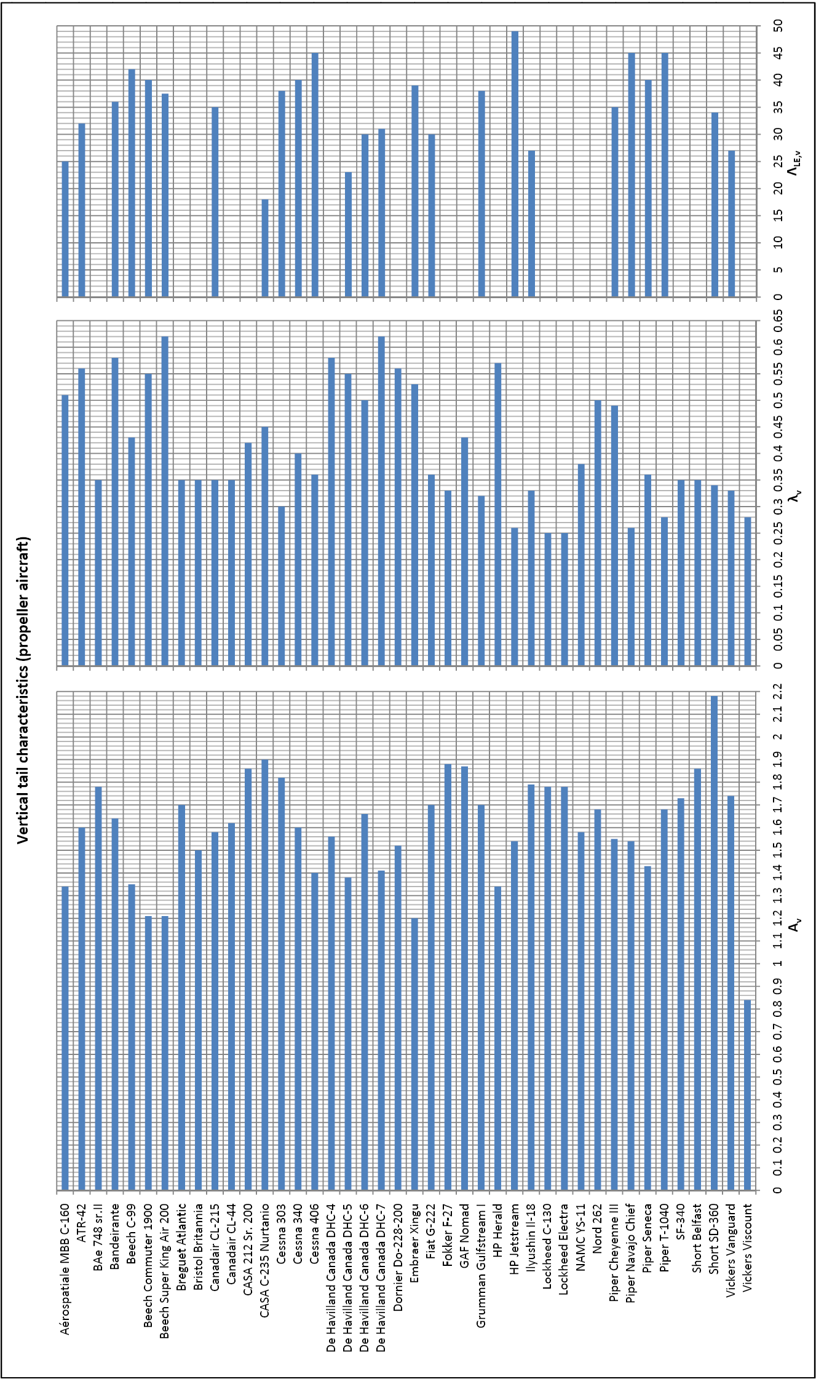
Figure 2.1: Vertical tail data propeller aircraft
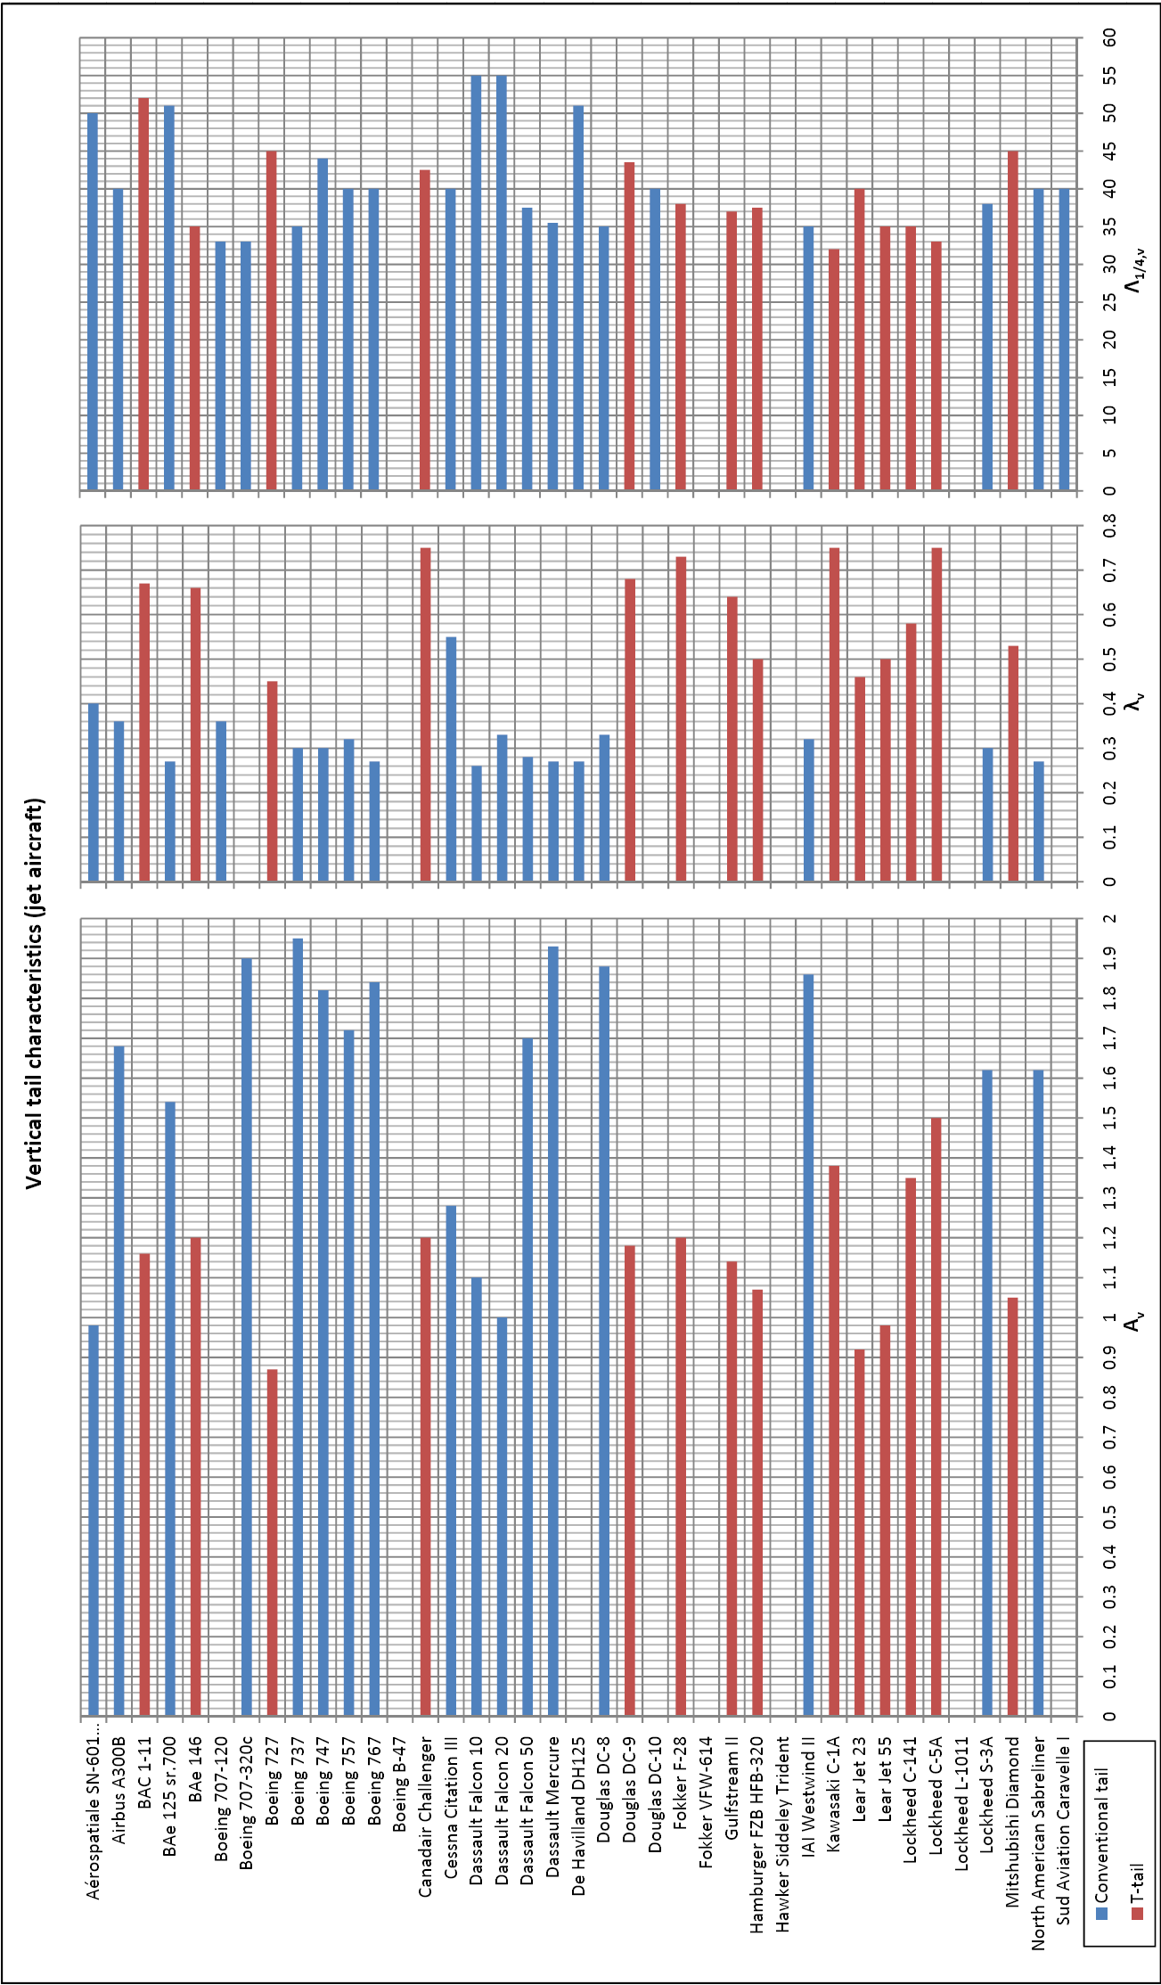
Figure 2.2: Vertical tail data jet aircraft

